Orchestration for batch processing

Orchestrate and monitor batch data pipelines
The well-designed and quality-controlled pipelines for Cymbal Superstore are effective, but they still exist as separate, isolated components.
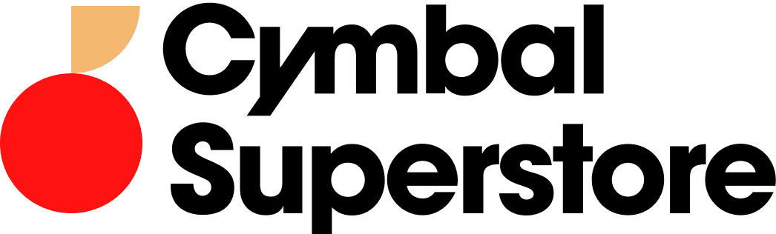
For the business to rely on them for daily financial operations, they cannot be triggered manually.
The true enterprise challenge lies in weaving these individual jobs into a single, cohesive, and automated workflow that runs reliably on a schedule, handles failures gracefully, and provides clear visibility into its operations.
This module is where you will build that operational framework. You will move far beyond the conceptual mention of DAGs and learn to develop and deploy them in Cloud Composer to automate your complex data processing lifecycle.
By the end of this module, you will have the skills to graduate your pipelines from individual components to a fully orchestrated, observable, and production-ready data system.
Watch the video below for an overview of the topics you'll cover in this lesson.
Click the play button to watch the video.

Transcript

Workflow orchestration
Cymbal Superstore's financial operations, including daily revenue reconciliation and customer invoicing, depend on a complex web of interconnected batch data pipelines.
- •
- Before sales data can be aggregated for reporting, it must first be ingested from point-of-sale systems, validated, and joined with product catalogs from a separate system.
- •
- Each of these steps is a distinct batch job, and they must execute in a specific order.
- •
- Manually triggering each job, waiting for it to complete, and then starting the next is an unreliable approach that is prone to failure.
This manual approach inevitably leads to delayed data availability, missed reporting deadlines, and significant operational overhead as the data team is forced to constantly address urgent problems reactively instead of building value.
In batch data processing, orchestration ensures that data moves seamlessly through its entire lifecycle with minimal human intervention.

Principles of orchestration
Click each button to expand the 5 items and learn more about key principles.

Dependency Management
This is the most crucial principle. It means defining the exact order of operations and enforcing the execution order.
For example, a task to transform data should only start after the task to ingest that data has completed successfully.

Scheduling
Automatically starting the entire workflow at a specific time (e.g., every day at 2:00 AM) or in response to an event (like a new file landing in a Cloud Storage bucket).

Error Handling and Retries
If a task fails due to a temporary glitch (like a brief network issue), the system should automatically try running it again a few times before giving up and alerting an operator.

Monitoring and Alerting
A centralized dashboard where you can see the status of all your workflows at a glance. If something fails permanently, the system should automatically send an alert (like an email or Slack message).

Idempotency
This is a vital design principle for your actual data jobs. An idempotent task is one that you can run multiple times with the same input, and it will always produce the same final result.
As data workloads scale and become more complex, orchestration becomes crucial for managing tasks, dependencies, and handling failures. It's important to understand that orchestration supports and coordinates services that process data, rather than processing the data directly.

Orchestration tools
Google Cloud provides several services for orchestration, each suited for different use cases:
Click each tab to learn more.
Cloud Scheduler
Workflows
Cloud Composer 3
Cloud Scheduler is designed for schedule-driven single-service orchestration, allowing you to trigger HTTP-based services at defined intervals using cron scheduling.
It's ideal for simple, recurring tasks.
While both Workflows and Cloud Composer can orchestrate multiple services and handle long-running workflows, they have distinct strengths:
Feature | Workflows | Cloud Composer 3
Primary use case | Ideal for service orchestration (chaining together APIs) | The go-to for complex, batch data pipelines (ETL/ELT).
Programming model | Uses a declarative approach with YAML/JSON, which is simple for straightforward sequences. | Uses Python, a full-fledged programming language, offering immense flexibility for dynamic and complex logic.
Latency | Designed for quick, event-driven execution with low startup overhead. | Its architecture, which relies on a scheduler and workers, introduces a few seconds of latency between tasks, making it appropriate for non-time-sensitive tasks.
Error handling/ retries | Built-in exception handling, automated HTTP call retries. Retry from a step is not possible. | Sophisticated task management, built-in scheduling, and features for unexpected behavior (e.g., sending email on failure). Allows retry from a step.
Logs and UI | Provides execution visualizations in the Google Cloud Console and integrates with Cloud Logging. | The Airflow UI provided by Composer is a purpose-built, rich interface designed specifically for debugging and managing data workflows, offering superior visibility with its graph views, task-specific logs, and operational tools.
The choice between the two services comes down to the specific use case:
- •
- Cloud Workflows: for lightweight, event-driven service orchestration with low latency requirements.
- •
- Cloud Composer: for robust, complex, and high-volume batch data processing pipelines where operational control and maintainability are critical.

Orchestration versus data processing engines
It's crucial to understand that orchestration tools and data processing engines are very different.
- •
- Orchestration tools are used for scheduling, managing, and monitoring complex data workflows, such as triggering a batch data pipeline at a specific time or in response to events. They do not directly process or transform big data itself, nor are they designed to pass large amounts of data between tasks. Instead, they make calls to other services like BigQuery or Dataflow to perform these operations.
- •
- Data processing engines (Dataflow or Serverless for Apache Spark) handle ETL, data integration, and analytics with automatic provisioning and scaling of resources. The engines are where you build your actual data pipelines for ingesting, processing, and transforming data, especially big data that requires performant aggregation and scaling.

Review
A data team runs a daily batch pipeline with several dependent steps (e.g., ingest, validate, transform).
What is the primary role of an orchestration tool like Cloud Composer in this process?
Click the button that has the correct response to the question above.

To process and transform the data itself.
This is incorrect because orchestration tools are not designed to perform large-scale data transformations. That is the job of a data processing engine like Dataflow or Spark, which the orchestration tool calls upon to execute the work. Think of the orchestrator as the project manager, not the worker doing the heavy lifting.

To manage the workflow, dependencies, and schedule.
Correct. The primary function of an orchestration tool is to act as the "manager" of the entire data pipeline. In this scenario, it would be responsible for triggering the pipeline at its scheduled time, ensuring that the "validate" step only begins after the "ingest" step has successfully completed, and alerting the team if any part of the workflow fails. It coordinates the work but does not perform the heavy data processing itself.

To handle lightweight, event-driven tasks.
This is incorrect because this describes the ideal use case for a different type of service, like Cloud Workflows
(opens in a new tab)
. While both are orchestrators, Cloud Composer is specifically built for complex, high-volume batch data pipelines that are not sensitive to a few seconds of latency between tasks. Lightweight, event-driven orchestration is better suited for services that require low latency and quick, event-based execution.

